Unit-1

ECS-232

COMPUTER NETWORKS

B.SRIDEVI

ASSISTANT PROFESSOR

DEPARTMENT OF CSE

**SYLLABUS**

**Computer networks and the Internet:** Internet, The Network Edge, The Network Core: Delay, Loss, and Throughput in Packet-Switched Networks, Protocol Layers, and Their Service Models, History of Computer Networking and the Internet.

**Computer Networks and the Internet**

-Today’s Internet is the largest engineered system ever created by mankind, with hundreds of millions of connected computers, communication links, and switches.

-Billions of users are connected via laptops, tablets, and smartphones; and with an array of new Internet-connected devices such as sensors, web cams, game consoles, picture frames, and even washing machines.

-Internet is a network of networks, and these networks connect with each other.

**INTERNET**

The Internet is a computer network that interconnects hundreds of millions of computing devices throughout the world.

-The word internet can be described in couple of ways.

* First, we can describe the nuts and bolts of the Internet, that is, the basic hardware and software components that make up the Internet.
* Second, we can describe the Internet in terms of a networking infrastructure that provides services to distributed applications.
* **A Nuts-and-Bolts Description**

-Computing devices were primarily traditional desktop PCs, workstations, and so-called servers that store and transmit information such as web pages and e-mail messages.

-Increasingly, non-traditional Internet end systems such as laptops, smartphones, tablets, TVs, gaming consoles, Webcam, automobiles, environmental sensing devices, picture frames, and home electrical and security systems are being connected to the Internet.

-In Internet jargon, all of these devices are called **hosts** or **end systems**.

-End systems are connected together by a network of **communication links** and **packet switches**.

* There are many types of communication links, which are made up of different types of physical media, including coaxial cable, copper wire, optical fiber, and radio spectrum.
* Different links can transmit data at different rates, and the **transmission rate** of a link is measured in bits/second.
* Packet switches are of different types, but the two most prominent types in today’s Internet are **routers** and **link-layer switches**.
* Both types of switches forward packets to their destinations.
* Link-layer switches are typically used in access networks, while routers are typically used in the network core.

-The sequence of communication links and packet switches traversed by a packet from the sending end system to the receiving end system is known as a **route** or **path** through the network.

-End systems access the Internet through **Internet Service Providers (ISPs)**

* Each ISP is itself a network of packet switches and communication links.
* The Internet is all about connecting end systems to each other, so the ISPs that provide access to end systems must also be interconnected.
* Lower-tier ISPs are interconnected through national and international upper-tier ISPs.
* An upper-tier ISP consists of high-speed routers interconnected with high-speed fiber-optic links.
* Each ISP network, whether upper-tier or lower-tier, is managed independently.

-End systems, packet switches, and other pieces of the Internet run **protocols** that control the sending and receiving of information within the Internet.

* The **Transmission Control Protocol (TCP)** and the **Internet Protocol (IP)** are the two most important protocols on the Internet.
* The IP protocol specifies the format of the packets that are sent and received among routers and end systems.

**-Internet standards** are developed by the Internet Engineering Task Force (IETF).

* It’s important that everyone agree on what each and every protocol does so that people can create systems and products according to it, this is where standards come into play.
* The IETF standards documents are called **requests for comments (RFCs)**.
* **A Services Description**

-The Internet can be described as an infrastructure that provides services to applications.

-These applications include electronic mail, web surfing, social networks, instant messaging, Voiceover-IP (VoIP), video streaming, distributed games, peer-to-peer (P2P) file sharing, television over the Internet, remote login, and much more.

-The applications are said to be **distributed applications**, since they involve multiple end systems that exchange data with each other.

**-**End systems attached to the Internet provide an **Application Programming Interface (API)** that specifies how a program running on one end system asksthe Internet infrastructure to deliver data to a specific destination program runningon another end system.

* **What Is a Protocol?**

A **protocol** defines the format and the order of messages exchanged between two or more communicating entities, as well as the actions taken on the transmission of a message or other event.

**Human Analogy**

-In human protocol, there are specific messages that are send, and specific actions that are taken in response to the received reply messages or other events.

-From the below figure human protocol dictates that one first offers a greeting to initiate communication with someone else.

-The typical response to a “Hi” is a returned “Hi” message. Implicitly, one then takes a cordial “Hi” response as an indication that one can proceed and ask for the time of day.

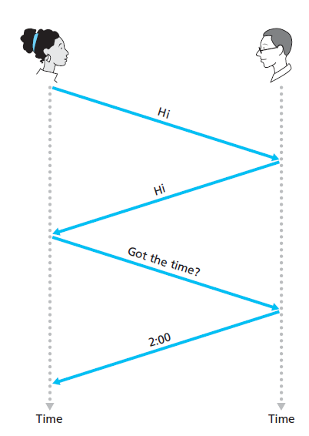

**Figure:** Human protocol

**Network Protocols**

-A network protocol is similar to a human protocol.

-All activities in the Internet involves two or more communicating remote entities governed by a protocol.

-Protocols are running everywhere in the Internet.

-From the below figure initially,

* The computer will send a connection request message to the Web server and wait for a reply.
* The Web server will eventually receive the connection request message and return a connection reply message.
* After receiving the reply message, the computer sends the name of the Web page it wants to fetch from that Web server in a GET message.
* Finally, the Web server returns the Web page (file) to the computer.

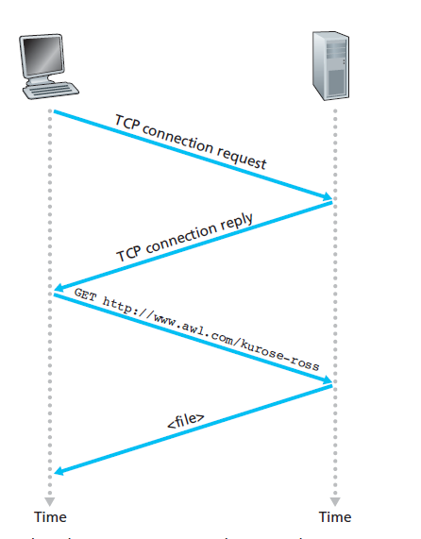

**Figure:** Computer Network protocol

**NETWORK EDGE**

-The Internet end systems include desktop computers (e.g., Desktop PCs, Macs, and Linux boxes), servers (e.g., Web and e-mail servers), and mobile computers (e.g., laptops, smartphones, and tablets).

-End systems are also referred to as hosts because they host (run) application programs such as a Web browser program, a Web server program, an e-mail client program, or an e-mail server program.

-Host = end system. Hosts are sometimes further divided into two categories: **clients** and **servers**.

* Informally, clients tend to be desktop and mobile PCs, smartphones, and so on; whereas servers tend to be more powerful machines that store and distribute Web pages, stream video, relay e-mail, and so on.
* **Access Networks**

The network that physically connects an end system to the first router (also known as the “edge router”) on a path from the end system to any other distant end system.

**Home Access: Digital Subscriber Line (DSL)**

-Residence typically obtains DSL Internet access from the same local telephone company (telco) that provides its wired local phone access.

-Each customer is provided with a DSL modem by the telephone company through which the customer accesses the internet.

-Each customer’s DSL modem uses the existing telephone line to exchange data with a digital subscriber line access multiplexer (DSLAM) located in the telco’s local central office (CO).

-The home’s DSL modem takes digital data and translates it to high frequency tones for transmission over telephone wires to the CO.

-The analog signals from many such houses are translated back into digital format at the DSLAM.

-On the customer side, a splitter separates the data and telephone signals arriving to the home and forwards the data signal to the DSL modem.

-On the telco side, in the CO, the DSLAM separates the data and phone signals and sends the data into the Internet.

-The residential telephone line carries both data and traditional telephone signals simultaneously, which are encoded at different frequencies:

* A high-speed downstream channel, in the 50 kHz to 1 MHz band.
* A medium-speed upstream channel, in the 4 kHz to 50 kHz band.
* An ordinary two-way telephone channel, in the 0 to 4 kHz band

-The downstream and upstream rates are different; the access is said to be asymmetric.

-DSL is designed for short distances between the home and the CO.

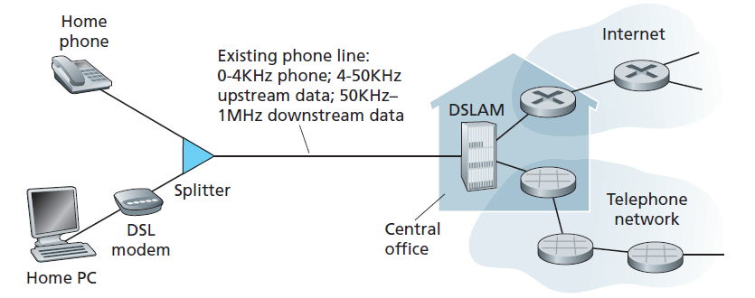

**Figure:** DSL Internet access

**Cable Internet Access**

-A residence obtains cable Internet access from the same company that provides its cable television.

-Fiber optics connect the cable head end to neighbourhood-level junctions, from which traditional coaxial cable is then used to reach individual houses and apartments.

-Each neighbourhood junction typically supports 500 to 5,000 homes.

-Because both fiber and coaxial cable are employed in this system, it is often referred to as hybrid fiber coax (HFC).

-Cable internet access requires special modems, called cable modems.

-The cable modem is typically an external device and connects to the home PC through an Ethernet port.

-At the cable head end, the cable modem termination system (CMTS) is used for turning the analog signal sent from the cable modems in many downstream homes back into digital format.

-Cable modems divide the HFC network into two channels, a downstream and an upstream channel.

-Important characteristic of cable Internet access is that it is a shared broadcast medium.

-If several users are simultaneously downloading a video file on the downstream channel, the actual rate at which each user receives its video file will be significantly lower than the aggregate cable downstream rate.

-On the other hand, if there are only a few active users and they are all Web surfing, then each of the users may actually receive Web pages at the full cable downstream rate.

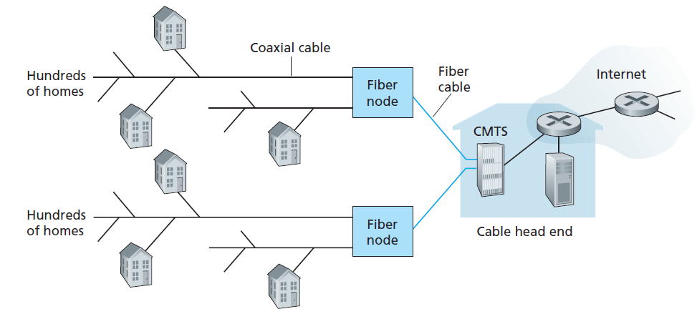

**Figure:** A hybrid fiber-coaxial access network

**Fiber to the Home**

-The FTTH provide an optical fiber path from the CO directly to the home.

-There are several competing technologies for optical distribution from the CO to the homes.

-The simplest optical distribution network is called direct fiber, with one fiber leaving the CO for each home.

* Each fiber leaving the central office is actually shared by many homes; it is not until the fiber gets relatively close to the homes that it is split into individual customer-specific fibers.
* There are two competing optical-distribution network architectures that perform this splitting: active optical networks (AONs) and passive optical networks (PONs).

-Each home has an optical network terminator (ONT), which is connected by dedicated optical fiber to a neighbourhood splitter.

-The splitter combines a number of homes (typically less than 100) onto a single, shared optical fiber, which connects to an optical line terminator (OLT) in the telco’s CO.

-The OLT, providing conversion between optical and electrical signals, connects to the Internet via a telco router.

-FTTH can potentially provide Internet access rates in the gigabits per second range.

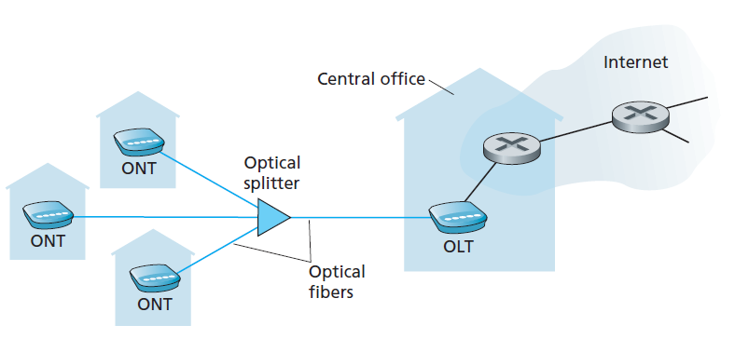

**Figure:** FTTH Internet access

**Access in the Enterprise**

-In corporate and university campuses, and increasingly in-home settings, a local area network (LAN) is used to connect an end system to the edge router.

-There are many types of LAN technologies, Ethernet is far the most prevalent access technology.

* Ethernet users use twisted-pair copper wire to connect to an Ethernet switch.
* The Ethernet switch, or a network of such interconnected switches, is then in turn connected into the larger Internet.
* With Ethernet access, users typically have 100 Mbps access to the Ethernet switch, whereas servers may have 1 Gbps or even 10 Gbps access.

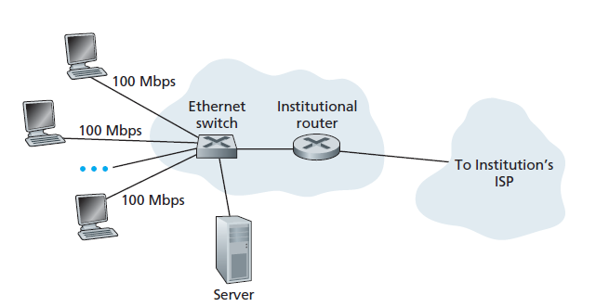

**Figure:** Ethernet Internet access

**Wide-Area Wireless Access**

-Wireless access network connects end system to router.

-Devices employ the same wireless infrastructure used for cellular telephony to send/receive packets through a base station that is operated by the cellular network provider.

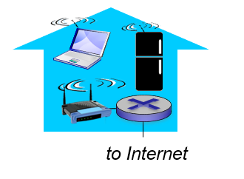

**Figure:** Wireless LAN’s

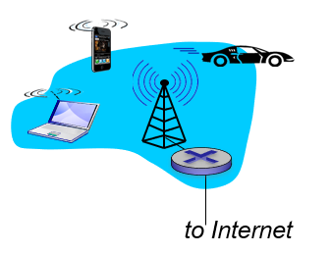

**Figure:** Wide Area Wireless Access

* **Physical Media**

-In each transmitter-receiver pair, the bit is sent by propagating electromagnetic waves or optical pulses across a **physical medium**.

-Physical link lies between transmitter and receiver.

-Physical media fall into two categories: **guided media** and **unguided media**.

* In guided media, the waves are guided along a solid medium, such as a fiber-optic cable, a twisted-pair copper wire, or a coaxial cable.
* In unguided media, the waves propagate in the atmosphere and in outer space, such as in a wireless LAN or a digital satellite channel.

**Twisted-Pair Copper Wire**

-The least expensive and most commonly used guided transmission medium is twisted-pair copper wire.

-It has been used by telephone networks.

-Twisted pair consists of two insulated copper wires, each about 1 mm thick.

-The wires are twisted together to reduce the electrical interference from similar pairs close by.

-Typically, a number of pairs are bundled together in a cable by wrapping the pairs in a protective shield.

-Data rates for LANs using twisted pair today range from 10 Mbps to 10 Gbps.

-The data rates can be achieved depending on the thickness of the wire and the distance between transmitter and receiver.

**Coaxial Cable**

-Coaxial cable consists of two copper conductors, but the two conductors are concentric rather than parallel.

-With this construction and special insulation and shielding, coaxial cable can achieve high data transmission rates.

-Coaxial cable is quite common in cable television systems.

-In cable television and cable Internet access, the transmitter shifts the digital signal to a specific frequency band, and the resulting analog signal is sent from the transmitter to one or more receivers.

-Coaxial cable can be used as a guided **shared medium**.

**Fiber Optics**

-An optical fiber is a thin, flexible medium that conducts pulses of light, with each pulse representing a bit.

-A single optical fiber can support tremendous bit rates, up to tens or even hundreds of gigabits per second.

-They are immune to electromagnetic interference, have very low loss of signal strength up to 100 kilometers, and are very hard to tap.

-These characteristics have made fiber optics the preferred guided transmission media.

**Terrestrial Radio Channels**

-Radio channels carry signals in the electromagnetic spectrum.

-They require no physical wire to be installed, can penetrate walls, provide connectivity to a mobile user, and can potentially carry a signal for long distances.

-The characteristics of a radio channel depend significantly on the propagation environment and the distance over which a signal is to be carried.

-Terrestrial radio channels can be broadly classified into three groups:

* Those that operate over very short distance (e.g., with one or two meters)
* Those that operate in local areas, typically spanning from ten to a few hundred meters.
* Those that operate in the wide area, spanning tens of kilometers.

**Satellite Radio Channels**

-A communication satellite links two or more Earth-based microwave transmitter/receivers, known as ground stations.

-The satellite receives transmissions on one frequency band, regenerates the signal using a repeater, and transmits the signal on another frequency.

-Two types of satellites are used in communications:

* **Geostationary Satellites:** Geostationary satellites permanently remain above the Earth. This stationary presence is achieved by placing the satellite in orbit at 36,000 kilometers above Earth’s surface. This huge distance from ground station through satellite back to ground station introduces a substantial signal propagation delay of 280 milliseconds
* **Low-Earth Orbiting (LEO) Satellites:** LEO satellites are placed much closer to Earth. They rotate around Earth (just as the Moon does) and may communicate with each other, as well as with ground stations.

**NETWORK CORE**

There are two fundamental approaches for moving data through a network of links and switches: **circuit switching** and **packet switching**.

* **Packet Switching**

-To send a message from a source end system to a destination end system, the source breaks long messages into smaller chunks of data known as **packets**.

-Between source and destination, each packet travels through communication links and **packet switches** (there are two predominant types, **routers** and **link layer switches**).

-Packets are transmitted over each communication link at a rate equal to the full transmission rate of the link.

-So, if a source end system or a packet switch is sending a packet of L bits over a link with transmission rate R bits/sec, then the time to transmit the packet is

**L/R seconds.**

**Store-and-Forward Transmission**

**-**Most packet switches use **store-and-forward transmission** at the inputs to the links.

-Store-and-forward transmission means that the packet switch must receive the entire packet before it begins to transmit the first bit of the packet onto the outbound link.

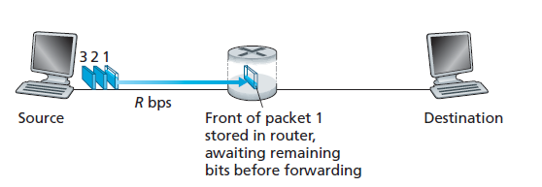

**Figure:** Store-and-forward packet switching

**-**From the above figure the source has three packets, each consisting of *L* bits, to send to the destination.

-At a time, the source has transmitted some of packet 1, and the front of packet 1 has already arrived at the router.

-As the router employs store-and-forwarding, at this instant of time, the router cannot transmit the bits it has received; instead, it must first buffer (i.e., “store”) the bits of a packet.

-Only after the router has received all of the packet’s bits it begins to transmit (i.e., “forward”) the packet onto the outbound link.

-The source begins to transmit at time 0

* At time *L*/*R* seconds, the source has transmitted the entire packet, and the entire packet has been received and stored at the router.
* At time *L*/*R* seconds, since the router has just received the entire packet, it can begin to transmit the packet onto the outbound link towards the destination; at time 2*L*/*R*, the router has transmitted the entire packet, and the entire packet has been received by the destination. Thus, the total delay is 2*L*/*R*.
* At time *L*/*R*, the router begins to forward the first packet, at the same time *L*/*R* the source will begin to send the second packet, since it has just finished sending the entire first packet.

At time 2*L*/*R*, the destination has received the first packet and the router has received the second packet. Similarly, at time 3*L*/*R*, the destination has received the first two packets and the router has received the third packet. Finally, at time 4*L*/*R* the destination has received all three packets.

* Sending one packet from source to destination over a path consisting of *N* links each of rate *R* and there are *N*-1 routers between source and destination then end-to-end delay is



**Queuing Delays and Packet Loss**

-Each packet switch has multiple links attached to it and has an **output buffer** (also called an **output queue**), which stores packets that the router is about to send.

-The output buffers play a key role in packet switching.

-If an arriving packet needs to be transmitted onto a link but finds the link busy with the transmission of another packet, the arriving packet must wait in the output buffer.

-In addition to the store-and-forward delays, packets suffer output buffer **queuing delays**.

* These delays are variable and depend on the level of congestion in the network.

-The amount of buffer space is finite; if an arriving packet finds that the buffer is completely full with other packets waiting for transmission then **packet loss** will occur.

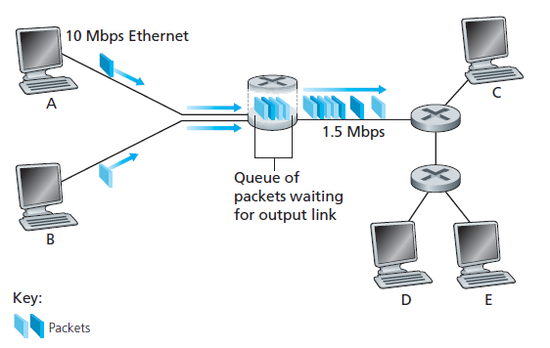

**Figure:** Packet Switching

**Forwarding Tables and Routing Protocols**

**-**End systems that access internet has an address called an IP address.

-When a source end system wants to send a packet to a destination end system, the source includes the destination’s IP address in the packet’s header and forwards it to the router.

-Each router has a **forwarding table** that maps destination addresses to that router’s outbound links.

* When a packet arrives at a router, the router examines the address and searches its forwarding table, using this destination address, to find the appropriate outbound link.

-The Internet has a number of special **routing protocols** that are used to automatically set the forwarding tables.

* **Circuit Switching**

-In circuit-switched networks, the resources needed along a path for communication between the end systems are reserved for the duration of the communication session between the end systems.

-In packet-switched networks, these resources are not reserved.

-The sender before sending the information, the network must establish a dedicated end-to-end connection between the sender and the receiver.

-The hosts are directly connected to one of the switches.

-In the below figure, each link has four circuits. Call gets 2nd circuit in top link and 1st circuit in right link.

-Circuit segment will be idle if not used by call (no sharing) commonly used in traditional telephone networks.

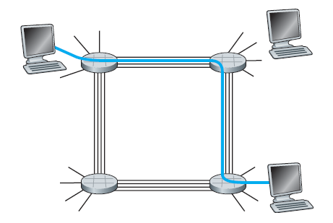

**Figure:** A simple circuit-switched network consisting of

four switches and four links

**Multiplexing in Circuit-Switched Networks**

-A circuit in a link is implemented with either **frequency-division multiplexing (FDM)** or **time-division multiplexing (TDM)**.

* With FDM, the frequency spectrum of a link is divided among the connections established across the link.
* The link dedicates a frequency band to each connection for the duration of the connection.
* The width of the band is called, the **bandwidth**.
* In TDM, time is divided into frames of fixed duration, and each frame is divided into a fixed number of time slots.
* These slots are dedicated for the use of that connection, with one time slot available for use (in every frame) to transmit the data.

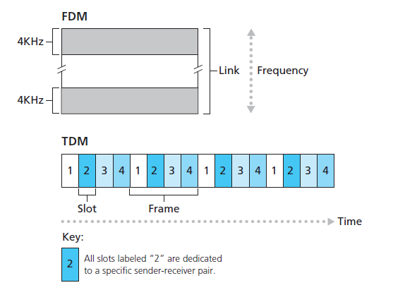

**Figure:** With FDM, each circuit continuously gets a fraction of the bandwidth. With TDM, each circuit gets all of the bandwidth periodically during brief intervals of time.

* **A Network of Networks**

-The end systems (PCs, smartphones, Web servers, mail servers, and so on) connect to the Internet via an access ISP (Internet Service Provider).

-The access ISP can provide either wired or wireless connectivity, using an array of access technologies including DSL, cable, FTTH, Wi-Fi, and cellular.

-Internet is complex system to understand, so the following is the incremental network structure:

* Each access ISP directly connect with every other access ISP.
* Such a mesh design is, of course, much too costly and difficult to maintain for the access ISPs.

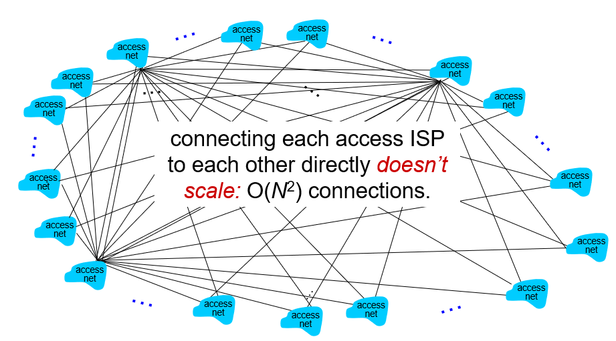

* Network Structure 1, interconnects all of the access ISPs with a single global transit ISP.
* Global transit ISP is a network of routers and communication links that not only spans the globe, but also has at least one router near each of the hundreds of thousands of access ISPs.
* It would be very costly for global ISP to build such an extensive network.
* The access ISP pays the global transit ISP, the access ISP is said to be a **customer** and the global transit ISP is said to be a **provider**.

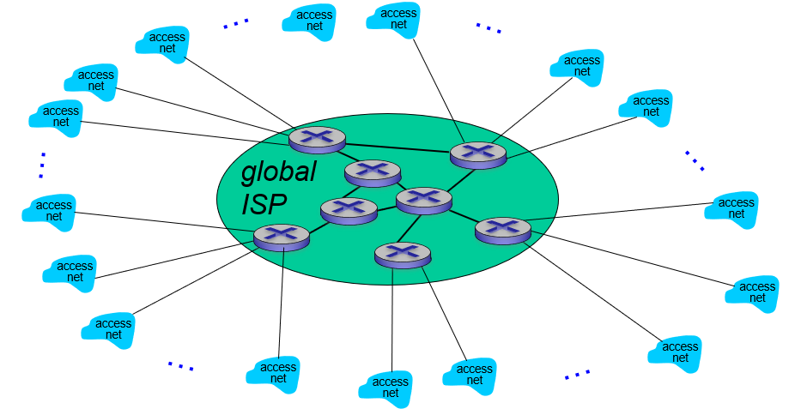

* Network Structure 2, which consists of the hundreds of thousands of access ISPs and multiple global transit ISPs.

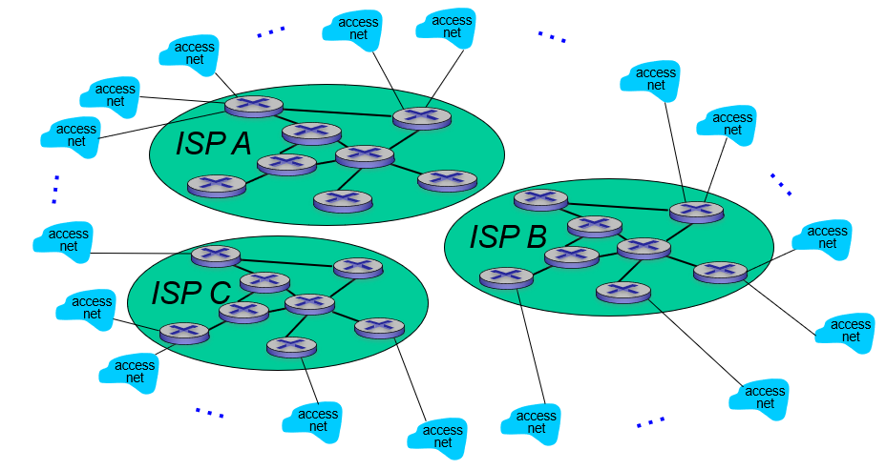

* The global transit ISPs themselves must interconnect: Otherwise access ISPs connected to one of the global transit providers would not be able to communicate with access ISPs connected to the other global transit providers.
* A third-party company can create an **Internet Exchange Point (IXP)** which is a

meeting point where multiple ISPs can peer together.

* Adding points of presence (PoPs), multi-homing, peering, and Internet exchange points (IXPs) to the hierarchical Network Structure 2.

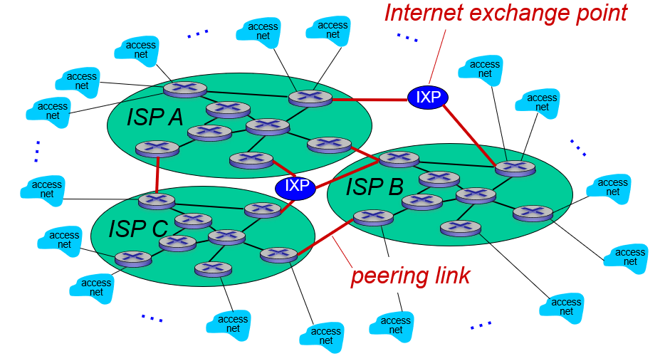

* There may be a **regional ISP** to which the access ISPs in the region can connect.

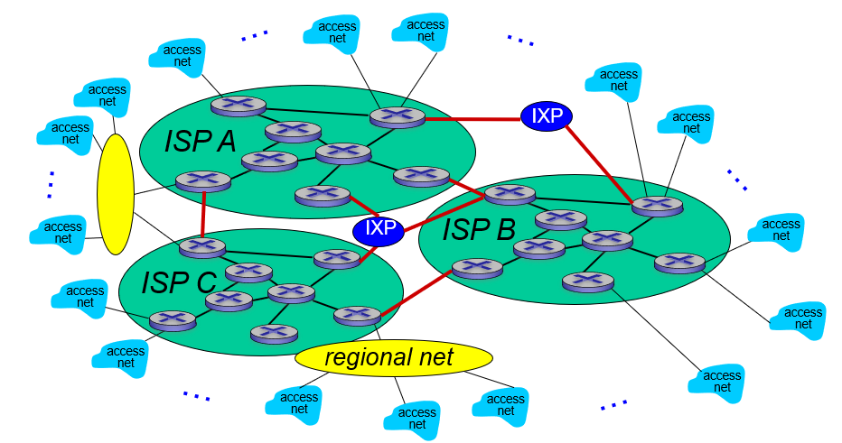

* In such a hierarchy, each access ISP pays the regional ISP to which it connects, and each regional ISP pays the tier-1 ISP to which it connects.
* The tier-1 ISPs do not pay anyone as they are at the top of the hierarchy.
* Consisting of access ISPs, regional ISPs, tier-1 ISPs, PoPs, multi-homing, peering, and IXPs—as Network Structure 4.
* Network Structure 5, builds on top of Network Structure 4 by adding **content provider networks**.
* Google is currently one of the leading examples of such a content provider network.

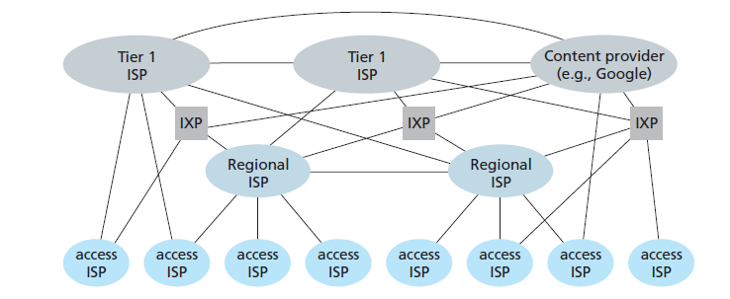

**Figure:** Interconnection of ISPs

**DELAYS, LOSS, AND THROUGHPUT IN PACKET-SWITCHED NETWORKS**

-A packet travels from one node (host or router) to the subsequent node (host or router) along the path, the packet suffers from several types of delays at each node along the path.

-The most important of these delays are the **nodal processing delay, queuing delay, transmission** **delay,** and **propagation delay**; together, these delays accumulate to give a **total** **nodal delay**.

-The performance of many Internet applications such as search, Web browsing, email, maps, instant messaging, and voice-over-IP are greatly affected by network delays.

* **Types of Delay**

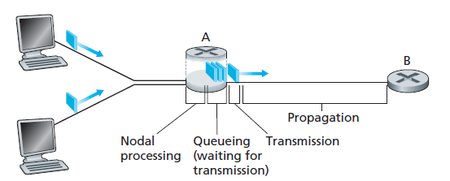

**Figure:** The nodal delay at router A

-End-to-end route between source and destination, a packet is sent from the upstream node through router A to router B. Our goal is to characterize the nodal delay at router A.

**Processing Delay:**

-The time required to examine the packet’s header and determine where to direct the packet is part of the **processing delay**.

-The processing delay can also include other factors, such as the time needed to check for bit-level errors in the packet that occurred in transmitting the packet’s bits from the upstream node to router A.

-Processing delays in high-speed routers are typically on the order of microseconds or less.

**Queuing Delay:**

-The packet experiences a **queuing delay** as it waits to be transmitted onto the link.

-The queuing delay of a specific packet will depend on the number of earlier-arriving packets that are queued and waiting for transmission onto the link.

* If the queue is empty and no other packet is currently being transmitted, then packet’s queuing delay will be zero.
* On the other hand, if the traffic is heavy and many other packets are also waiting to be transmitted, the queuing delay will be long.

-Queuing delays can be on the order of microseconds to milliseconds.

**Transmission Delay:**

-The packets are transmitted in a first-come-first-served manner, the packet can be transmitted only after all the packets that have arrived before it has been transmitted.

-Denote the length of the packet by L bits, and denote the transmission rate of the link from router A to router B by R bits/sec.

-The **transmission delay** is L/R.

-This is the amount of time required to push (that is, transmit) all of the packet’s bits into the link.

-Transmission delays are typically on the order of microseconds to milliseconds.

**Propagation Delay:**

-The bits are pushed into the link, it needs to propagate to router B.

-The time required to propagate from the beginning of the link to router B is the **propagation**

**delay**.

-The bit propagates at the propagation speed of the link.

-The propagation speed depends on the physical medium of the link.

-The propagation delay is the distance between two routers divided by the propagation speed.

* The propagation delay is d/s, where d is the distance between router A and router B and s

is the propagation speed of the link.

**Comparing Transmission and Propagation Delay:**

**-**The difference between transmission delay and propagation delay is subtle but important.

-The transmission delay is the amount of time required for the router to push out the packet; it is a function of the packet’s length and the transmission rate of the link, but has nothing to do with the distance between the two routers.

-The propagation delay, on the other hand, is the time it takes a bit to propagate from one router to the next; it is a function of the distance between the two routers, but has nothing to do with the packet’s length or the transmission rate of the link.

-Consider dproc, dqueue, dtrans, and dprop denote the processing, queuing, transmission, and propagation delays, then the total nodal delay is given by



* **Queuing Delay and Packet Loss**

-The most complicated and interesting component of nodal delay is the queuing delay, dqueue.

-Unlike the other three delays (namely, dproc, dtrans, and dprop), the queuing delay can vary from packet to packet.

* + For example, if 10 packets arrive at an empty queue at the same time, the first packet transmitted will suffer no queuing delay, while the last packet transmitted will suffer a relatively large queuing delay.

-The queuing delay will be large depending on the rate at which traffic arrives at the queue, the transmission rate of the link, and the nature of the arriving traffic.

-Let ‘a’ denote the average rate at which packets arrive at the queue (a is in units of packets/sec),’R’ is the transmission rate; that is, it is the rate (in bits/sec) at which bits are pushed out of the queue, all packets consist of ‘L’ bits.

-Then the average rate at which bits arrive at the queue is La bits/sec.

-The ratio La/R, called the **traffic intensity**.

-If La/R > 1, then the average rate at which bits arrive at the queue exceeds the rate at which the bits can be transmitted from the queue.

-The case La/R is close to zero then the packet arrivals are few and far between and it is unlikely that an arriving packet will find another packet in the queue.

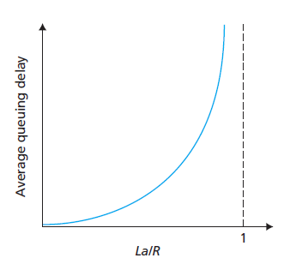

**Figure:** Dependence of average queuing delay on traffic intensity.

* **End-to-End Delay**

-Now consider the total delay from source to destination.

-Suppose there are N - 1 routers between the source host and the destination host.

-Suppose for the moment that the network is uncongested (so that queuing delays are negligible)

-The nodal delays accumulate and give an end-to-end delay,



**Traceroute**

-For end-to-end delay in a computer network, **traceroute program** is used.

-Traceroute is a simple program that can run in any Internet host.

-When the user specifies a destination hostname,

* + The program in the source host sends multiple, special packets toward that destination.
  + As these packets work their way toward the destination, they pass through a series of routers.
  + When a router receives one of these special packets, it sends back to the source a short message that contains the name and address of the router.
  + Suppose there are *N* -1 router between the source and the destination.
  + Then the source will send *N* special packets into the network.
  + When the *n*th router receives the *n*th packet marked *n,* the router does not forward the packet toward its destination, but instead sends a message back to the source.
  + When the destination host receives the *N*th packet, it too returns a message back to the source.
  + The source records the time that elapses between when it sends a packet and when it receives the corresponding return message; it also records the name and address of the router (or the destination host) that returns the message.
* **Throughput in Computer Networks**

-One of the critical performance measure in computer networks is end-to-end throughput.

-Throughput is defined as rate (bits/time unit) at which bits transferred between sender/receiver.

-The **instantaneous throughput is the rate** at any instant of time.

-The file consists of F bits and the transfer takes T seconds to receive all F bits, then the **average throughput** of the file transfer is F/T bits/sec.

**PROTOCOL LAYERS AND THEIR SERVICE MODELS**

-Internet is an extremely complicated system.

-The Internet consists of numerous applications and protocols, various types of end systems, packet switches, and various types of link-level media.

* **Layered Architecture**

**Layering**

Layering means decomposing the problem of building a network into more manageable components (called layers).

**Benefits:** More modular design and easy to troubleshoot.

**Protocol Layering**

-Network designers organize protocols and the network hardware and software that implement the protocols in **layers**.

-Each protocol belongs to one of the layers.

-The **services** that a layer offers to the layer above is called **service model** of a layer.

-A protocol layer can be implemented in software, in hardware, or in a combination of the two.

-Application layer protocols such as HTTP and SMTP are almost always implemented in software on the end systems; so are transport-layer protocols.

-The physical layer and data link layers are responsible for handling communication over a specific link, they are typically implemented in a network interface card (for example, Ethernet or WiFi interface cards) associated with a given link.

-The network layer is often a mixed implementation of hardware and software.

-The protocols of the various layers are called the **protocol** **stack**.

-The Internet protocol stack consists of five layers: the physical, link, network, transport, and application layers.

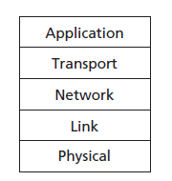

**Figure:** Five-layer Internet protocol stack

**Application Layer:**

-The application layer is where network applications and their application-layer protocols reside. -The Internet’s application layer includes many protocols, such as

* HTTP protocol: Hyper Text Transfer Protocol provides for Web document request and transfer.
* SMTP: Simple Mail Transfer Protocol provides for the transfer of e-mail messages.
* FTP: File Transfer Protocol provides for the transfer of files between two end systems.
* DNS: Domain Name System is used for translation of human-friendly names for Internet end systems like www.ietf.org to a 32-bit network address.

-An application-layer protocol is distributed over multiple end systems, with the application in one end system using the protocol to exchange packets of information with the application in another end system.

-The packet of information at the application layer is referred as a **message**.

**Transport Layer:**

-The transport layer transports application-layer messages between application endpoints.

-In the Internet there are two transport protocols, TCP and UDP, either of which can transport application-layer messages.

* TCP provides a connection-oriented service to its applications.
* This service includes guaranteed delivery of application-layer messages to the destination and flow control.
* The UDP protocol provides a connectionless service to its applications.

**-**TCP also breaks long messages into shorter segments. In transport-layer packet is known as a **segment**.

**Network Layer:**

**-**The Internet’s network layer is responsible for moving network-layer packets known as **datagrams** from one host to another.

-The network layer then provides the service of delivering the segment to the transport layer in the destination host.

-The Internet’s network layer includes the IP Protocol, which defines the fields in the datagram.

-The Internet’s network layer also contains routing protocols that determine the routes that datagrams take between sources and destinations.

**Link Layer:**

**-**The Internet’s network layer routes a datagram through a series of routers between the source and destination.

-To move a packet from one node (host or router) to the next node in the route, the network layer relies on the services of the link layer.

-It is also responsible for physical addressing.

-In particular, at each node, the network layer passes the datagram down to the link layer, which delivers the datagram to the next node along the route.

-In the link layer the packets are referred as **frames**.

**Physical Layer:**

**-**The physical layer is to move the individual bits within the frame from one node to the next.

-The protocols in this layer are again link dependent and further depend on the actual transmission medium of the link.

-A bit is moved across the link in a different way.

**The OSI Model**

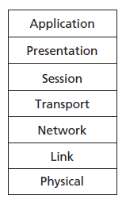

**Figure:** Seven-layer ISO OSI reference model

-The International Organization for Standardization (ISO) proposed that computer networks be organized around seven layers, called the Open Systems Interconnection (OSI) model.

-The seven layers of the OSI reference model, are: application layer, presentation layer, session layer, transport layer, network layer, data link layer, and physical layer.

-**Presentation layer:** A Presentation layer is mainly concerned with the syntax and semantics of the information exchanged between the two systems.

* **Translation:**

-It converts the data from sender-dependent format into a common format and changes the common format into receiver-dependent format at the receiving end.

* **Encryption:**

-Encryption is needed to maintain privacy.

-Encryption is a process of converting the sender-transmitted information into another form and sends the resulting message over the network.

* **Compression:**

-Data compression is a process of compressing the data, i.e., it reduces the number of bits to be transmitted.

-Data compression is very important in multimedia such as text, audio, video.

-**Session Layer:** The Session layer is used to establish, maintain and synchronizes the interaction between communicating devices.

* **Dialog control:**

-Session layer acts as a dialog controller, it allows the communication between two processes which can be either half-duplex or full-duplex.

* **Synchronization:**

-Session layer adds some checkpoints when transmitting the data in a sequence.

-If some error occurs in the middle of the transmission of data, then the transmission will take place again from the checkpoint.

* **Encapsulation**

-The physical path that data takes down a sending end system’s protocol stack, up and down the protocol stacks of an intervening link-layer switch and router, and then up the protocol stack at the receiving end system.

-Similarly, routers and link-layer switches organize their networking hardware and software into layers.

* + But routers and link-layer switches do not implement all of the layers in the protocol stack; they typically implement only the bottom layers.
  + The Internet routers are capable of implementing the IP protocol, while link-layer switches are not.
  + Link-layer switches do not recognize IP addresses, they are capable of recognizing layer 2 addresses, such as Ethernet addresses.

-At the sending host, an **application-layer message(M)** is passed to the transport layer.

-Then the transport layer takes the message and appends additional information (so-called transport-layer header information, Ht) that will be used by the receiver-side transport layer to deliver the message up to the appropriate application and error-detection bits that allow the receiver to determine whether bits in the message have been changed in route.

-The application- layer message and the transport-layer header information together constitute the **transport-layer segment**.

-The transport-layer segment thus encapsulates the application-layer message.

-The transport layer then passes the segment to the network layer, which adds network-layer header information (Hn) such as source and destination end system addresses, creating a **network-layer datagram**.

-The datagram is then passed to the link layer, which will add its own link-layer header information and create a **link-layer frame**.

-At each layer, a packet has two types of fields: header fields and a **payload field**.

-The payload is typically a packet from the layer above.

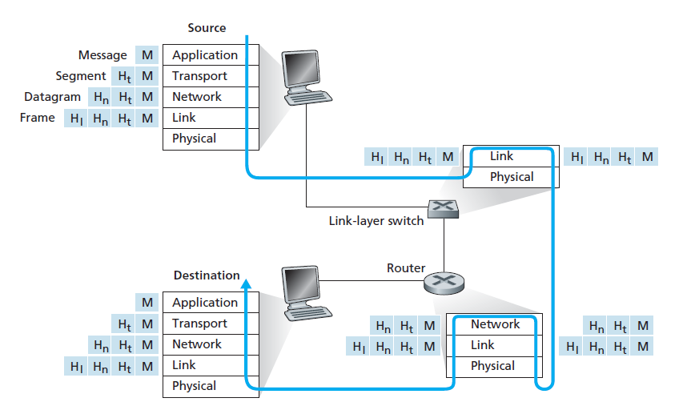

**Figure:** Hosts, routers, and link-layer switches; each contains a

different set of layers, reflecting their differences in functionality